 | 7.1.33 Editors - 3D Viewport - Header - Grease Pencil - Edit mode - Point menu
Table of content
Edit Mode - Point Menu 1
Extrude 1
Smooth 1
Last Operator Smooth Stroke 1
Repeat 1
Factor 2
Selected points 2
Position 2
Thickness 2
Strength 2
UV's 2
Merge 2
Last Operator Merge Strokes 2
Mode 2
Draw on back 2
Additive drawing 2
Cyclic 2
Dissolve Points 2
Delete Strokes 3
Vertex Groups 3
Add New Group 3
Assign 3
Remove 3
Select 3
Deselect 3

Edit Mode - Point Menu

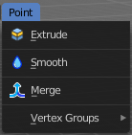
Extrude
Extrudes out the selected points. The new points stay connected with the original points of the stroke.

Smooth
Smoothens out the selected geometry.

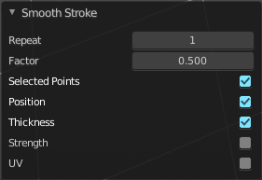
Last Operator Smooth Stroke

Repeat
How often to repeat the procedure.

Factor
The amount of the smoothness to apply.

Selected points
When enabled, limits the effect to only the selected points within the stroke.

Position
When enabled, the operator affect the points location.

Thickness
When enabled, the operator affect the points thickness.

Strength
When enabled, the operator affect the points strength (alpha).

UV's
When enabled, the operator affect the UV rotation on the points.

Merge
Allows you to paint a new stroke between the selected vertices. The selected points are not merged though, but a new stroke is created.

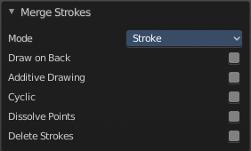
Last Operator Merge Strokes

Mode
Choose between stroke or point mode.
This feature is not documented in the Blender manual, there is no explanation in the tool tip, and it is not to find out what the difference is. Both do the same.

Draw on back
Draw the new stroke below all other strokes.

Additive drawing
Add to previous drawing

Cyclic
Close the new stroke

Dissolve Points
Dissolve the old selected points.

Delete Strokes
Deletes the old selected strokes.

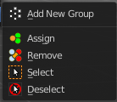
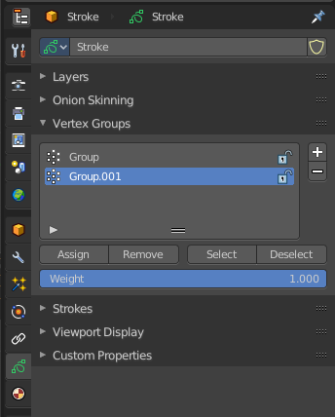
Vertex Groups
This menu contains just the Add New Group button as long as no vertex group exists.

Add New Group
Adds a new group.

Assign
Assign the current selected geometry to the current active group.

Remove
Removes the current selected geometry from the current active group.

Select
Select the geometry of the current active group.

Deselect
Deselect the geometry of the current active group.

